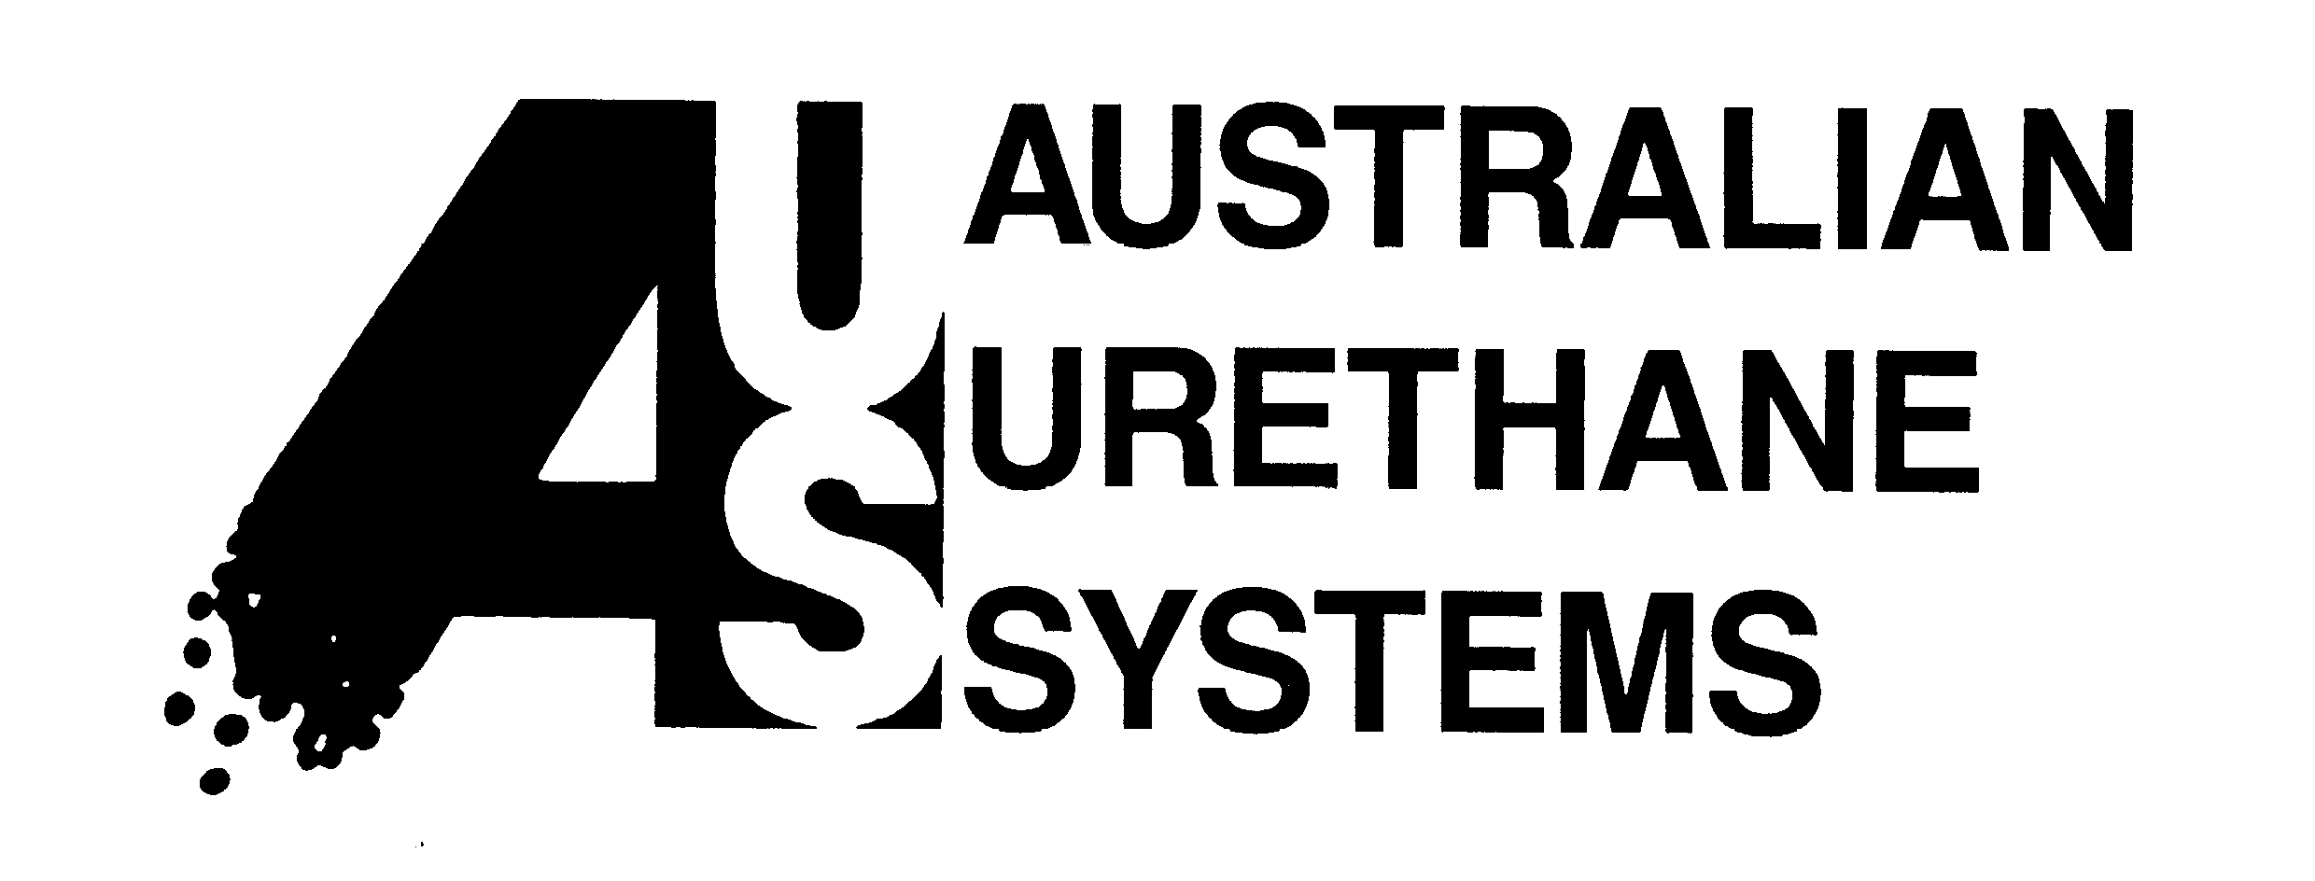

AUSTRALIAN URETHANE SYSTEMS PTY LIMITED
A.C.N. 000 168 874

25 Garling Road PHONE: (02) 9678 9833
Kings park NSW 2148 FAX: (02) 9678 9887
AUSTRALIA

THERMAL INSULATION OF RIGID POLYURETHANE FOAM

Polyurethane foam is generally described in the technical literature as having the lowest thermal conductance amongst a range of common thermal insulation material. Expanded polystyrene (EPS) and low density (20-50 kg/m³) rigid polyurethane foam systems significantly have gained the highest market acceptance for applications where low thermal/heat transmission is required in designed system- refrigeration cold rooms and in industrial /commercial applications where high insulation value systems are required.

This note aim to simply explain the terminology used and the use of thermal property values in heat flow calculation for rigid polyurethane foam systems

The basic definition are given for k value, R value, U value and the example calculations show how these concepts are used to compare/calculate heat flow through Insulation Systems.

The R-value of a material or system is called the thermal resistance. It is the actual measured thermal resistance of the insulating material at a particular thickness. Higher R-value is an indication of a better and more efficient insulating material.
The units for R value is m² ºC/W, it is calculated by the formula:

R= r x thickness (in metres)

Where r = 1/k
r- thermal resistivity (mºC/W)
k- thermal conductivity (W/mºC)

The k-value of a material is the most commonly expressed thermal property of materials.
Tables of k-values are reported in a wide range of texts and product information sheets. The k-value of a material is a direct measure of its ability to conduct heat.
It is the actual quantity of heat measured in Watts (W) that a square metre of the material will transmit in a unit time through a unit thickness (m) per ºC of temperature difference.

Hence k=W/mºC or W/mK

Where K is degree Kelvin

The lower the k-value the better the insulation property of that material.

Typical values for common building materials

Material | Density kg/m³ | k value W/m°C
Fibre insulation board | 220-300 | 0.049-0.057
Cork granules | 115 | 0.052
Glass wool | 65-160 | 0.041
Vermiculite  -loose granules | 100 | 0.065
Rock wool  -low density | 100 | 0.037
Expanded polystyrene | 15 | 0.035
Rigid polyurethane foam | 30-35 | 0.023

Thermal Conductivity of some Blowing Agents

In order to produce a foam, it is necessary to generate nucleating bubbles within the gelling mixture. Such blowing or foaming action can be attained by using either or both of the following:

- a physical blowing agent (eg R11, 141B), usually a solvent with low boiling point which evaporates off by the heat of the reactions.
- a chemical blowing agent (water), which undergoes chemical reactions with the isocyanate to liberate a gaseous product (carbon dioxide).

In Australia, R11, due to it effect on the ozone layer, has recently been replaced by 141B. The Ozone Depletion Factor (ODP) of 141B is only 0.11. This mean that it is about 10% of the ODP for R11 and tests showed that thermal conductivity for the two gases are almost identical.

The use of blowing agent(s) fulfils several functions:
- since it partially absorb the heat of reaction during evaporation it leads to closed cells
- it is fairly insoluble in the polymer, but it is soluble in the liquid mixture
- it exhibits only a slight tendency to diffuse through the cell walls so that it remains within the cells

The low thermal conductivity of rigid polyurethane foam is due to the use of 141B. Thermal conductance of the foam is a combination of several factors:
- thermal conductivity of the cell gas
- thermal conductivity of the cell material
- convection of the cell gas
- thermal radiation.

As long as the foam has fine cells, only the first two factors play an important role in thermal conductance. Even so, the effect of cell material is minimal because the chemical composition of cell polymer comprises only 3-6% of the volume.

Thermal conductivity of some cell gases at 0 °C

Gas type | Thermal conductance  (W/mK)
Air | 0.0243
Carbon dioxide | 0.0148
Fluorotrichloromethane (R11) | 0.0079

What is the effect of aging on the insulation characteristics of rigid polyurethane foam?

Significant investigation has been carried out into the effect of aging on the insulation value of PUR foam. In general terms PUR foam will gradually lose between 10 to 30% of its initial k-value over a 2 to 4 years period and then stabilise at this level. The small loss of thermal insulation value is not generally significant. It is due to the diffusion of carbon dioxide out of the foam and air is diffuses in.

Thermal Transmittance value (U)

Thermal transmittance is the value for the thermal performance of an element of a structure, comprising of one or more materials, of a given total thickness. It is a measure of its ability to transmit heat under steady state conditions. The unit for U is W/ m² ºC

In general terms: U= 1
R1+R2+R3+….

Where R1, R2, etc. are the individual thermal resistance values for the various materials and the surface/air resistance.

The higher the R-values of the materials that make up the building system, the smaller the U-value and the more efficient is the element in reducing the flow of heat (ie. a better insulator).

High U-value is associated with poor thermal insulation.
Low U-values is associated with good thermal insulation.

